AFRICA

BOHMAN, ERICA
Kenya Africa
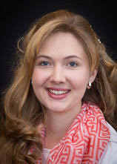

FASINRO, YINKA & VANESSA
Nigeria, West Africa
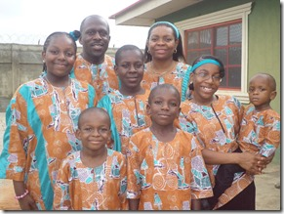

KEARNEY, FREDRICK & ANTOINETTE
Ghana West Africa
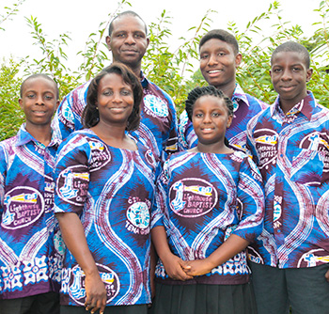

ASIA

WARD, HENRY & CELESTE
Kobe, Hyogo Prefecture, Kita-ku, Japan
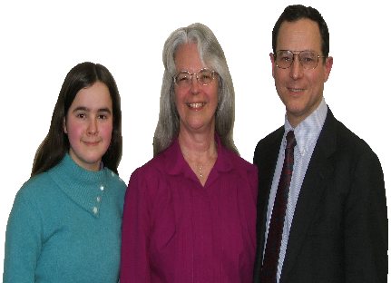

AU, ANDREW & ELENA
Hong Kong, China
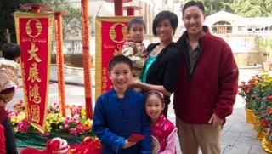

LONG, DAVID & TERRI
Couva, Trinidad, WI
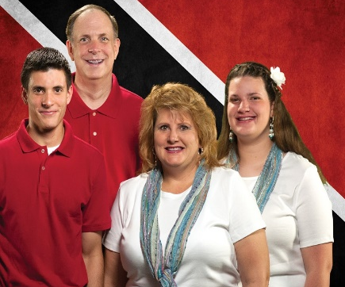

WILSON, ETHEL
Okosuka-Shi, Kanagawa-Ken, Japan
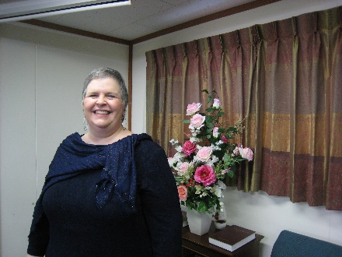

WYNN, JOHN & CHRISTI
Tacloban, Leyte, Philippines
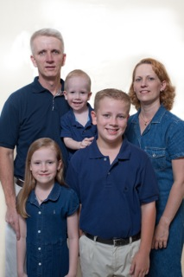

HAYES, JUSTIN & GRACE
Dos Hermanas, Spain
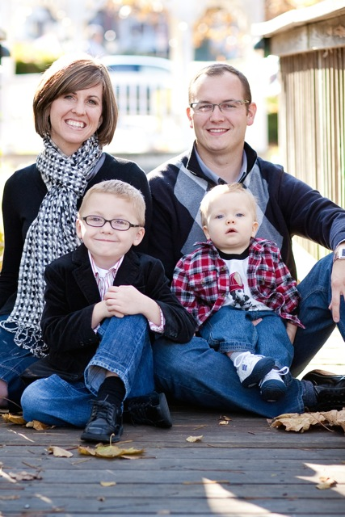

EUROPE

WAR, CHRIS & LOU ANNE
U.S. Military, Aviano, Italy
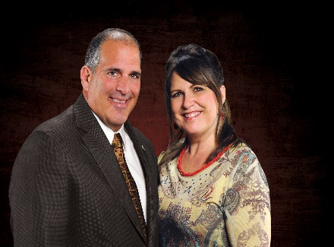

HORNBECK, JOHN & LEEETTA
U.S. Military, Aviano, Italy
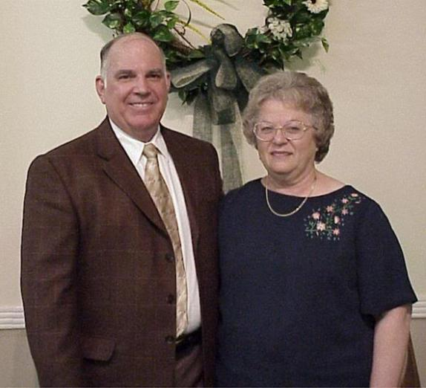

NORTH AMERICA

BEARD, ED & MARY
Annapolis, MD
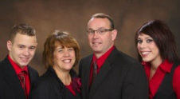

BURWELL, CLIFF CHARLOTTE
Evangelist, U.S.A
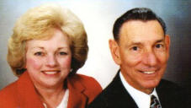

CAUDLE, JOHN & DEBORAH
Ontaria, Canada
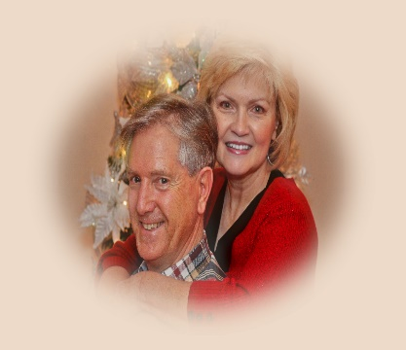

DOVE, JR., RICK & SHANNON
Atenas, Costa Rico
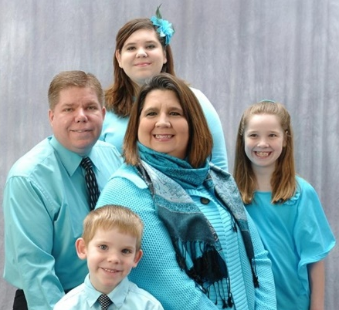

EASTEP, SAMUEL & BRENDA
Mexico City, Mexico
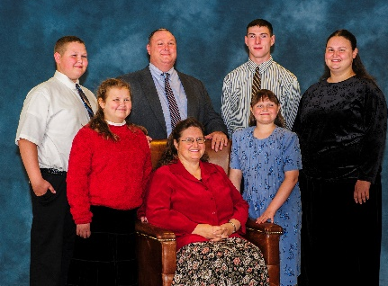

GARRIS, ANTHONY & BRENDA
Inner City Baptist Church, NJ
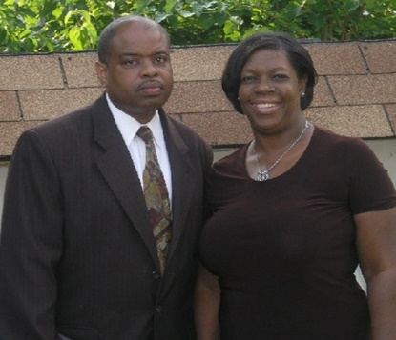

INDEP CHURCH PLANTING
DelMarVa

JEHOVAH JIREH MINISTRIES
James & Lois Bosse
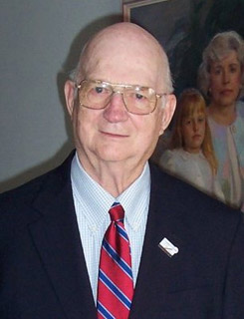

KEAST, WAYNE & TERRI
AFBM, Fayetteville, NC
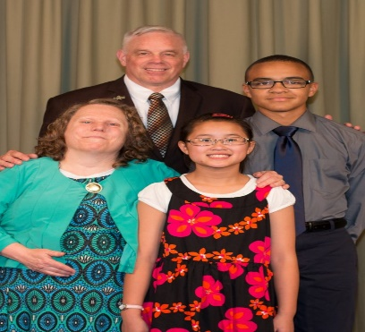

LIGHTHOUSE LEGAL MINISTRY, Robideau, Jim
Ohio
Christian Legal
Outreach Ministry
Christian Legal
Outreach Ministry

MCKEEVER, LINDA
Ministry of Ladies, USA
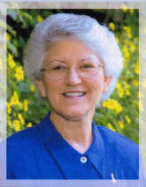

PAYNE, RICARDO & MARY
Washington, DC

PHELPS, CHUCK & SUE
Grain Valley, Missouri
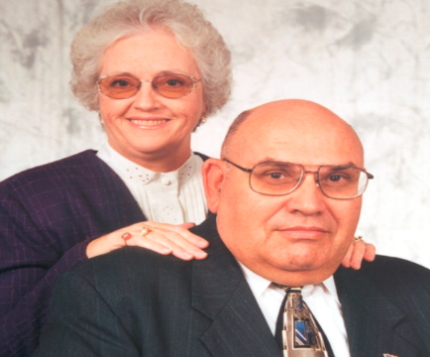

SMITH, SHELTON
SOL Publisher, Mission Outreach, USA
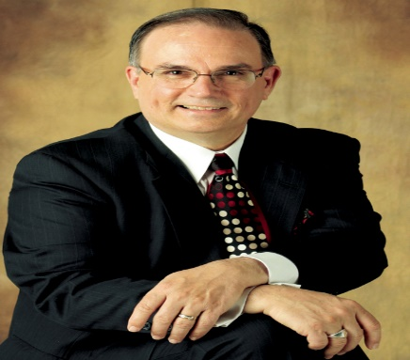

OCEANIC

OTTOSEN, JASON & CHERITH
Gulf Province, Papua New Guinea
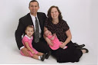

HALL, JON & MARIE
Taree, New South Wales Australia
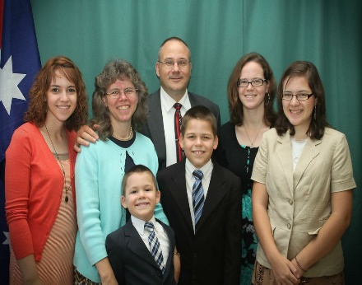

HERBERLE, JIM & BECKY
Outback Queensland, Australia
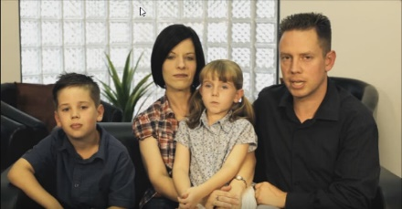

SOUTH AMERICA

LAWSON, BRIAN & JESSICA
Brazil
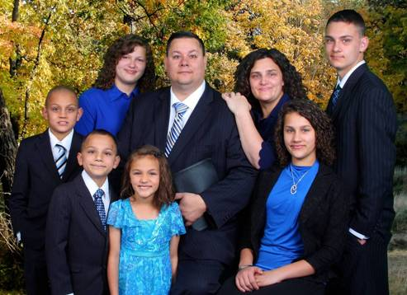

SMITH, ROBERT & CATHY
Sao Paulo Brazil
